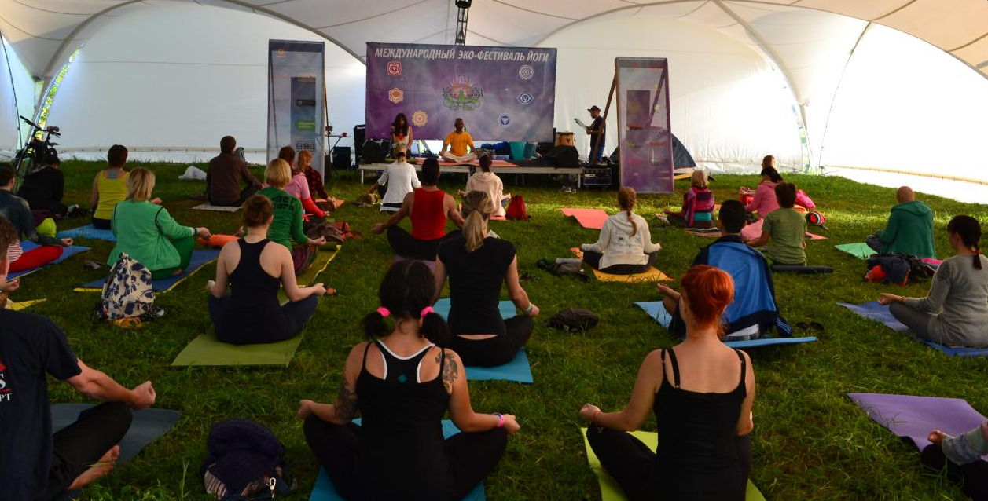

Yoga Teacher Training Retreat In Goa, India (200 Hours)

Traditional Hatha / 28 Days / Yoga Alliance Certification
28 days / 200 hours Yoga Teacher Training in Goa, India, to experience the genuine practice of traditional Hatha yoga and Hatha vinyasa in a peaceful environment. 50 % of the course content is focused on training new teachers with detailed practice and teaching methodologies of the asanas. While rest of the course content is focused on improving Pranayamas, Meditation and a practical philosophy to combine the physical practice. This yoga teacher training Retreat in India is not only for would be yoga teachers, but also for anybody wanting to make a shift and trying to find a meaningful purpose in Life.
This 200 hour Yoga Teacher Training in India covers all the basic techniques and skills to get started on the path of yoga – in a professional way by spreading love and light. Even if you are not interested in teaching yoga, the practices and philosophy will enrich your body, mind and intellect, and also to understand the purpose of life and know-how to live a peaceful life in this material world.

Every TTC course is enough to get intellectual enlightenment if there are two things: first one is; the teacher should have the capacity to share his knowledge with clarity and the second one is; the student must need thirst for knowledge which helps one to ask relevant questions. Water always flows from the higher to the lower ground, so the student should be humble in front of the teacher: then only sharing will happen in an easy natural way.

Eligibility:
- Required qualifications to enroll in this course is your intention to help others by sharing your experiences after having learned the value of Life. We would be even happier if:
- You are a regular yoga follower.
- You are a good listener, especially as a spiritual seeker.
- You would love to do early meditation and ready to handle all the emotional imbalance which may arise during the course.
- You are passionate to question and challenge your own beliefs on who am I, purpose of life…

COURSE STANDARDS AND CONTENTS

Techniques Training / Practice — 105 Hours: Includes asanas, pranayamas, kriyas, mantra, meditation, and other traditional yoga techniques. These hours are a mix between (1) analytical training in how to teach and practice, and (2) guided practice of the techniques.
Teaching Methodology — 25Hours: Includes principles of demonstration, observation, assisting /correcting, instruction, teaching styles, qualities of a teacher, the student’s process of learning, and business aspects of teaching yoga.
- Yoga Anatomy & Physiology — 20-Hours: Includes both human physical anatomy and physiology (bodily systems, organs, etc.) and energy anatomy and physiology (chakras, Nadis, etc.). Includes both the study of the subject and application of its principles to yoga practice (benefits, contraindications, healthy movement patterns, etc).
- Philosophy, Lifestyle & Ethics — 30 Hours: Includes the study of Yoga Sutras that helps one to get intellectual enlightenment, historical evolution of yoga and various techniques for Self-Realization, yogic lifestyle which helps to develop discipline and willpower, and ethics for yoga teachers.
- Practicum — 20 Hours: Includes practice teaching, receiving feedback, observing others teaching and hearing/giving feedback.
Qualities of a teacher: People usually come to our classes not just to learn some yoga poses but to find solutions for their problems in life. Giving one’s time to listen to the problems of others, allowing them to relax, uplifting their confidence by assuring: ‘Aall izz Well’, loving them heart-fully etc., are some of the qualities that one should uphold as a human being. We will be sharing about the importance of voice, peaceful presence, as well as safety precautions.
Business aspects of teaching yoga: A seminar will be provided that can give you a clear idea about business ethics and values that one should keep as a good yoga teacher.

Daily Schedule

6:00 –6.30 am | Guided Meditations
6:40 –6.50 am | Neti/Kriyas
7:00 – 9:00 am | Pranayama & Asana Practice.
9:00 – 10:30 am | Breakfast
10:30 – 12:00 pm | Philosophy/ Anatomy class
12:00 – 13:00 pm | Time to clear doubts with teachers/ Learn new asanas
13.00 – 14.00 | Lunch
15:00 – 16.00 | Bhagavat Gita/Ayurveda
16.00 –16:30 | Tea Break
16.30 – 18.00 | Alignment/Teaching Methodology/Adjustments Training.
18:00 – 19:00 | Student teaching/Asana Practice
19.00 – 20.00 | Dinner
20.00 - 20.30 | Bhajans
22.00 – 9.00 | Silence/Mindfulness

This time table is subject to change.
Classes are held 6 days a week. The 7th day is Holiday.

Yoga Alliance Certification

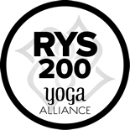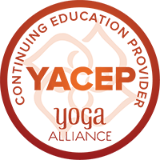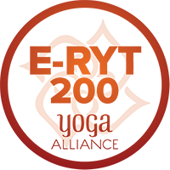

Our 200 Hour Yoga TTC comprehensively meets the Standards defined by the Yoga Alliance, and exceeds in all respects as we enhance the program with other activities.
YOGA PRANIDHANA is a Yoga Alliance Registered Yoga School (RYS). After the successful completion of the course with us, you are eligible to be a member of Yoga Alliance and Yoga Alliance registered yoga teacher (RYT) by means of registering yourself on yoga alliance directory by uploading a copy of your certificate.
This certification will help you to get hired and start teaching Yoga. The certificate is recognized and carries a lot of weight all over the world. For more details about Yoga Alliance, please visit their website www.yogaalliance.org.

Upcoming dates for 200 hr Yoga Teacher Training Courses

December 3, 2019 to December 30, 2019
January 3, 2020 to January 30, 2020
February 1, 2020 to February 28, 2020
March 3, 2020 to March 30, 2020

Venue

Our upcoming Teacher Training Courses will take place in Secret Garden Resort (http://www.secretgardenpatnem.com), South Goa, India.

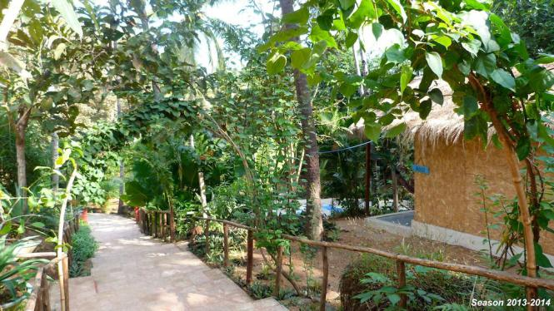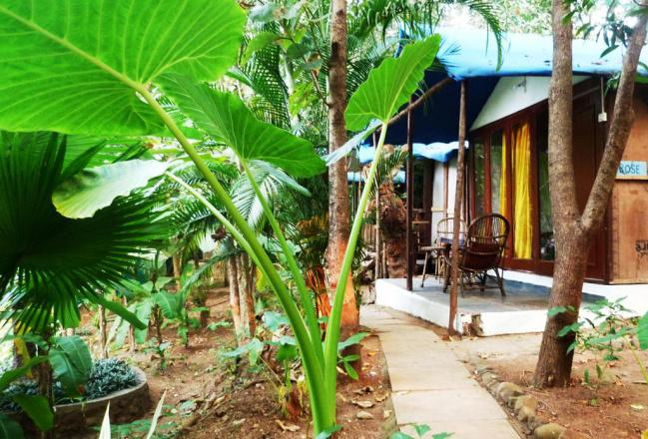

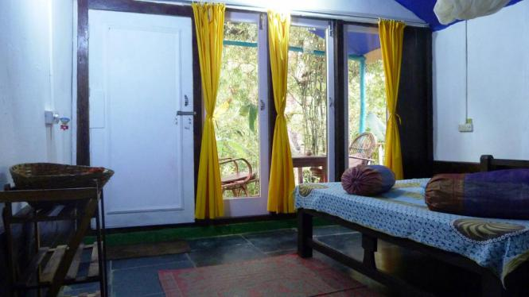

Pricing

With Accommodation |  | Without Accommodation
Single | Double shared | 1300 €
2300 € | 2000 € | 1300 €

For double shared accommodation please email us to check the availability prior to booking.

2300 € / 2000 € Packages Include:
- Registration Fee.
- Accommodation for 28 days.
- Tuition Fee.
- TTC Study materials
- Yoga Pranidhana kit (2 T-shirts, Yoga bag, Study materials, Stainless Steel Water Bottle, Note Book, Pen).
- Vegetarian Breakfast, Lunch & Dinner throughout the course (Except Holidays).
- Two Herbal Teas Daily and & Filtered Drinking Water.
- Does NOT include airport pick up and drop off.

1300 € Package Includes:
- Registration Fee
- Tuition Fee
- TTC Study materials
- Yoga Pranidhana kit (2 T-shirts, Yoga bag, Study materials, Stainless Steel Water Bottle, Note Book, Pen)
- Vegetarian Breakfast, Lunch & Dinner throughout the course (Except Holidays)
- Two Herbal Teas Daily and & Filtered Drinking Water
- Does NOT include airport pick up, drop off and accommodation

How to Register/ Apply:
Please fill up the Online Application Form and mail it to us in order to register for 200 Hour Yoga Teacher Training Course. Your application will be processed and you will be kept informed through email.

